Geometric Poisson distribution

Alias

Geometric Possion distribution

Polya-Aeppli distribution

Intro

Geometric Possion distribution

is used for describing objects that come in clusters, where the number of clusters follows a [Poisson distribution](https://en.wikipedia.org/wiki/Poisson_distribution) and the number of objects within a cluster follows a [geometric distribution](https://en.wikipedia.org/wiki/Geometric_distribution).[[1]](https://en.wikipedia.org/wiki/Geometric_Poisson_distribution#cite_note-FOOTNOTEJohnsonKotzKemp2005410-1) It is a particular case of the [compound Poisson distribution](https://en.wikipedia.org/wiki/Compound_Poisson_distribution).[[2]](https://en.wikipedia.org/wiki/Geometric_Poisson_distribution#cite_note-FOOTNOTENuel2008-2)

PDF

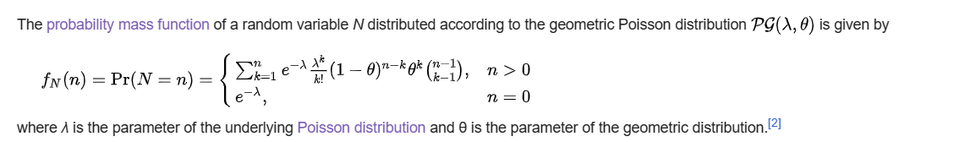

Ref

[Geometric Poisson distribution - Wikipedia](https://en.wikipedia.org/wiki/Geometric_Poisson_distribution)